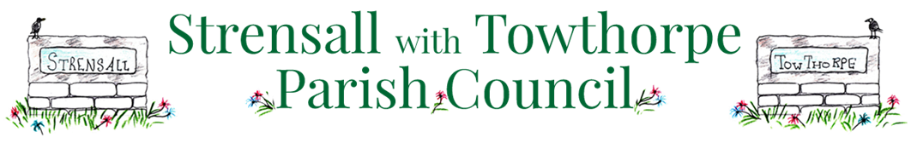
SUMMARY OF THE NEIGHBOURHOOD PLAN
Following the various stages of consultation, a number of key matters have been identified by residents and addressed within the Plan with a view to shaping development in the future. In particular, the Plan sets out policies concerning the following matters.

CAR PARKING: A number of local streets suffer from pressures for on-street parking, so the Plan aims to protect existing parking provision and make sure sufficient parking is provided as part of any future development.
COMMUNITY FACILITIES: The Plan aims to retain existing community facilities.
LOCAL GREENSPACE: Areas of open space that are considered to be important to the community are to be protected.
DESIGN: The Plan identifies the attributes of the Parish and sets out policies to protect and enhance the appearance of the villages.
MANAGING CHANGE: A number of specific areas within Strensall have been identified due to their vulnerability to development in the future. The Plan sets out planning considerations to help shape development.
AFFORDABLE HOUSING: Securing affordable housing to meet local housing needs is supported.
COMMUNITY ACTIONS: The Neighbourhood Plan also includes a number of Community Actions. These are not strictly planning matters, but given their importance to the community then the Plan sets out how the Parish Council intends to address them in the future.

The Parish Council welcomes your views on the contents of the Neighbourhood Plan before it is submitted to City of York Council for examination.
THE DEADLINE FOR COMMENTS IS 5 PM ON 26th AUGUST 2019
FOR VERIFICATION PURPOSES, PLEASE ENTER YOUR DETAILS

NAME…………………………………….. POSTCODE:………………………

QUESTIONNAIRE
Please use this questionnaire to provide us with your thoughts on the draft Plan. Please tick a box to say whether you agree or disagree with the policy, and feel free to comment too.

Policy CP1: Safeguarding Existing Car Parking
 Agree  Disagree
Comment:

Policy CP2: Increased Public Car Parking
 Agree  Disagree
Comment:

Policy CF1: Protection of Community Facilities and Services
 Agree  Disagree
Comment:

Policy CF2: Local Green Space
 Agree  Disagree
Comment:

Policy DH1: Promotion of Local Distinctiveness
 Agree  Disagree
Comment:

Policy DH2: General Design Principles
 Agree  Disagree
Comment:

Policy DH3: Shopfront Design
 Agree  Disagree
Comment:

Policy DH4: Shopfront Signage
 Agree  Disagree
Comment:

Policy DG1: Strensall Park
 Agree  Disagree
Comment:

Policy DG2: Alexandra Road
 Agree  Disagree
Comment:

Policy DG3: Howard Road
 Agree  Disagree
Comment:

Policy DG4: Queen Elizabeth Barracks
 Agree  Disagree
Comment:

Policy DG5: Development Brief for the Redevelopment of the Queen Elizabeth Barracks
 Agree  Disagree
Comment:

Policy DG6: Affordable Housing
 Agree  Disagree
Comment:

Community Actions
CA….
 Agree  Disagree
Comment:

Once consultation has ended, we will consider the responses before amending and finalising the Plan. This final version of the Plan will then be submitted to City of York Council for examination.

Please return the completed questionnaire before 26th August 2019 to:
Parish Clerk,
Strensall with Towthorpe Parish Council,
The Village Hall,
Northfields,
Strensall,
YORK,
YO32 5XW

